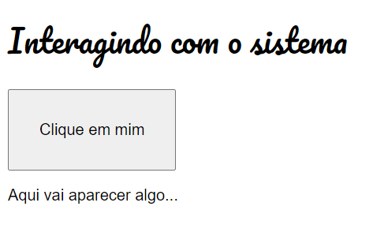

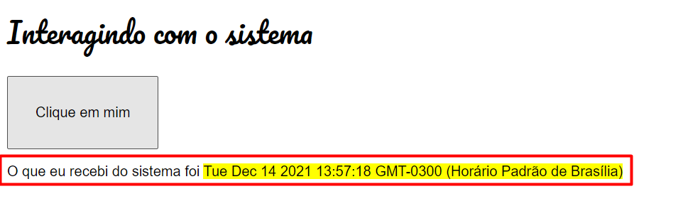

<!DOCTYPE html>

<html lang="pt-br">

<head>

    <meta charset="UTF-8">

    <meta name="viewport" content="width=device-width, initial-scale=1.0">

    <title>Interagindo com o sistema</title>

    <link rel="stylesheet" href="style.css">

</head>

<body>

    <h1>Interagindo com o sistema</h1>

    <button onclick="info()">Clique em mim</button>

    <section id="saida">

        <p>Aqui vai aparecer algo...</p>

    </section>

    <script src="functions.js"></script>

</body>

</html>

STYLE.CSS

@import url('https://fonts.googleapis.com/css?family=Pacifico&display=swap');

body { font: 12pt Arial; }

h1, h2, h3 { font-family: 'Pacifico', cursive; font-weight: normal;}

button { font-size: 12pt; padding: 30px; }

functions.js

function info() {

    let agora = new Date

    let saida = document.getElementById('saida')

    saida.innerHTML = `<p>O que eu recebi do sistema foi <mark>${agora}</mark></p>`

}